index.html

<!DOCTYPE html>

<html lang="en">

<head>

<title>Cummins College Of Engineering</title>

<meta charset="utf-8" />

<meta name="viewport" content="width=device-width, initial-scale=1" />

<link

rel="stylesheet"

href="https://maxcdn.bootstrapcdn.com/bootstrap/4.5.2/css/bootstrap.min.css"

/>

<link rel="stylesheet" type="text/css"

href="https://cdnjs.cloudflare.com/ajax/libs/font-awesome/5.13.1/css/all.min.css">

<link rel="stylesheet" href="./assets/style/style.css" />

<script src="https://ajax.googleapis.com/ajax/libs/jquery/3.5.1/jquery.min.js"></script>

<script src="https://cdnjs.cloudflare.com/ajax/libs/popper.js/1.16.0/umd/popper.min.js"></script>

<script src="https://maxcdn.bootstrapcdn.com/bootstrap/4.5.2/js/bootstrap.min.js"></script>

</head>

<body>

<header>

<div id="header-section" class="text-center">

<div class="container">

<div class="row">

<div class="col-md-6 col-sm-6 logo"></div>

<div class="col-md-6 col-sm-6">

<p class="mt-4">

MKSSS’s Cummins College of Engineering for Women,<br />Karvenagar,

Pune – 411052

</p>

</div>

</div>

</div>

</div>

<nav class="navbar navbar-expand-lg navbar-dark bg-dark static-top">

<div class="container">

<button

class="navbar-toggler"

type="button"

data-toggle="collapse"

data-target="#navbarResponsive"

aria-controls="navbarResponsive"

aria-expanded="false"

aria-label="Toggle navigation"

>

<span class="navbar-toggler-icon"></span>

</button>

<div class="collapse navbar-collapse" id="navbarResponsive">

<ul class="navbar-nav mr-auto">

<li class="nav-item active">

<a class="nav-link" href="#"

>Home

<span class="sr-only">(current)</span>

</a>

</li>

<li class="nav-item">

<a class="nav-link" href="register.html">Register</a>

</li>

<li class="nav-item">

<a class="nav-link" href="courses.html">Courses</a>

</li>

<li class="nav-item">

<a class="nav-link" href="contact.html">Contact Us</a>

</li>

</ul>

</div>

</div>

</nav>

</header>

<div class="main-container">

<div class="container mt-5">

<div class="row">

<div class="col-md-4">

<h4>Recent Achievements</h4>

<div class="card h-100">

<div class="card-body">

<div class="card-text">

<ul class="px-3">

<li>

Proud to announce- Cummins College of Engineering for

Women ranking in National Institutional Ranking Frameworks

(NIRF) for the year 2020 is "173"

</li>

<li>

Proud to announce- Outlook’s annual ranking of India’s

Best Engineering Colleges, Cummins College All India

Ranking is 45, and ranked 20th in the Private Engineering

colleges and Ranked 3rd in Pune.

</li>

</ul>

</div>

</div>

</div>

</div>

<div class="col-md-8">

<h4>About Us</h4>

<p>

MKSSS's Cummins College of Engineering for Women, Pune MH India an

Autonomous Institute affiliated to Savitribai Phule Pune

University. CCEW is considered to be one of the best colleges for

Engineering in the eastern states. Cummins college has been given

an ‘A’ grade by NAAC in the year 2012 and then from 2017 to 2019.

The undergraduate and postgraduate degrees provided by the Cummins

college are affiliated to the Savitribai Phule Pune University.

This is the world's one of the best college. So join Us!

</p>

<a href="register.html"><button style="margin: 10px 0" ; type="button"

class="btn btn-outline-dark">Register</button></a>

<a href="contact.html"><button style="margin: 10px 20px" ; type="button"

class="btn btn-outline-dark">Contact us</button></a>

</div>

</div>

<div id="courses" class="mt-5">

<h4>Our Courses</h4>

<p>MKSSS Cummins College of Engineering offers 3 courses.</p>

<div class="row">

<div class="col-lg-4 col-sm-6 mb-4">

<div class="card h-100">

<a href="courses.html#001"

><img

class="card-img-top"

src=".\assets\img\computer.jpg"

alt=""

/></a>

<div class="card-body">

<h5 class="card-title">Computer Engineering</h5>

<p class="card-text">

To equip women with excellent education in Computer

Engineering, enabling them to play significant leadership

roles in technology and society<br>

<a href="courses.html#001"><button style="margin: 10px 0" ; type="button"

class="btn btn-outline-dark">Know more--></button></a>

</p>

</div>

</div>

</div>

<div class="col-lg-4 col-sm-6 mb-4">

<div class="card h-100">

<a href="courses.html#002"

><img

class="card-img-top"

src=".\assets\img\electrical1.jpg"

alt="" width="700px" height="260px"

/></a>

<div class="card-body">

<h5 class="card-title">Electrical Engineering</h5>

<p class="card-text">

To provide excellent technical education for women in

Electronics and Telecommunication engineering in the global

context<br>

<a href="courses.html#002"><button style="margin: 10px 0" ; type="button"

class="btn btn-outline-dark">Know more--></button></a>

</p>

</div>

</div>

</div>

<div class="col-lg-4 col-sm-6 mb-4">

<div class="card h-100">

<a href="courses.html#003"

><img

class="card-img-top"

src=".\assets\img\mechanical.jpg" width="700px" height="260px"

alt=""

/></a>

<div class="card-body">

<h5 class="card-title">Mechanical Engineering</h5>

<p class="card-text">

To be recognized as a centre for quality education to

develop women professionals in mechanical engineering<br><br>

<a href="courses.html#003"><button style="margin: 5px 0" ; type="button"

class="btn btn-outline-dark">Know more--></button></a>

</p>

</div>

</div>

</div>

</div>

</div>

</div>

</div>

<!---------------------------Footer----------------->

<footer class="mt-5">

<div id="footer-section">

<div class="container">

<div class="container1">

<!-- <h3>Footer</h3> -->

<span><a href="https://www.linkedin.com" target="_blank">linkedin</a><i class="fab fa-linkedin"></i></span>

<span><a href="https://www.facebook.com" target="_blank">Facebook</a><i class="fab fa-facebook"

aria-hidden="true"></i></span>

<span> <a href="https://www.twitter.com" target="_blank">Twitter</a><i class="fab fa-twitter"

aria-hidden="true"></i></span>

<span> <a href="https://www.instagram.com" target="_blank">Instagram</a><i class="fab fa-instagram"

aria-hidden="true"></i></span>

<span> <a

href="mailto:support@gmail.com"

target="_blank">Mail</a><i class="far fa-envelope" aria-hidden="true"></i></span>

</div>

</div>

</div>

</footer>

</body>

</html>

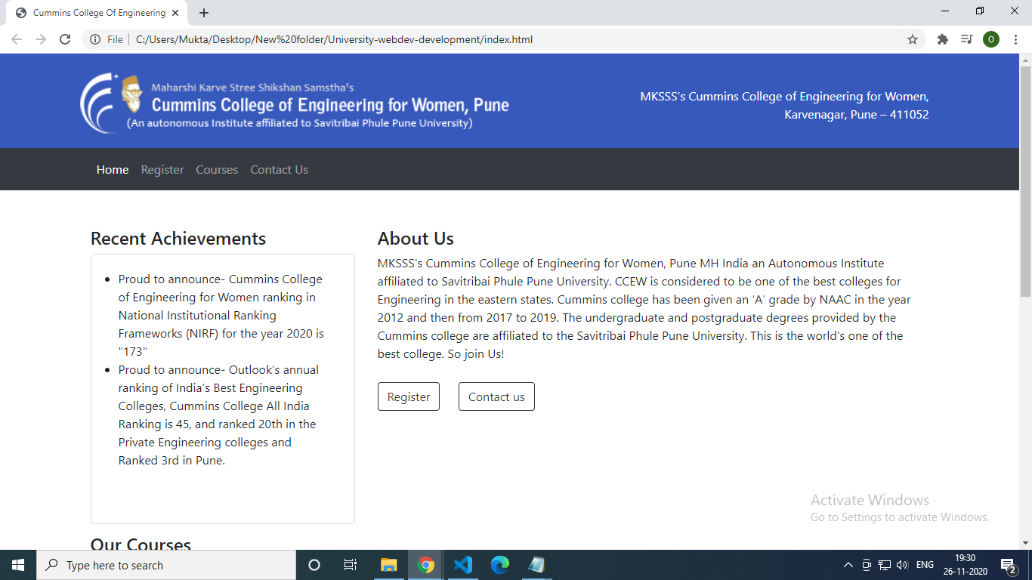

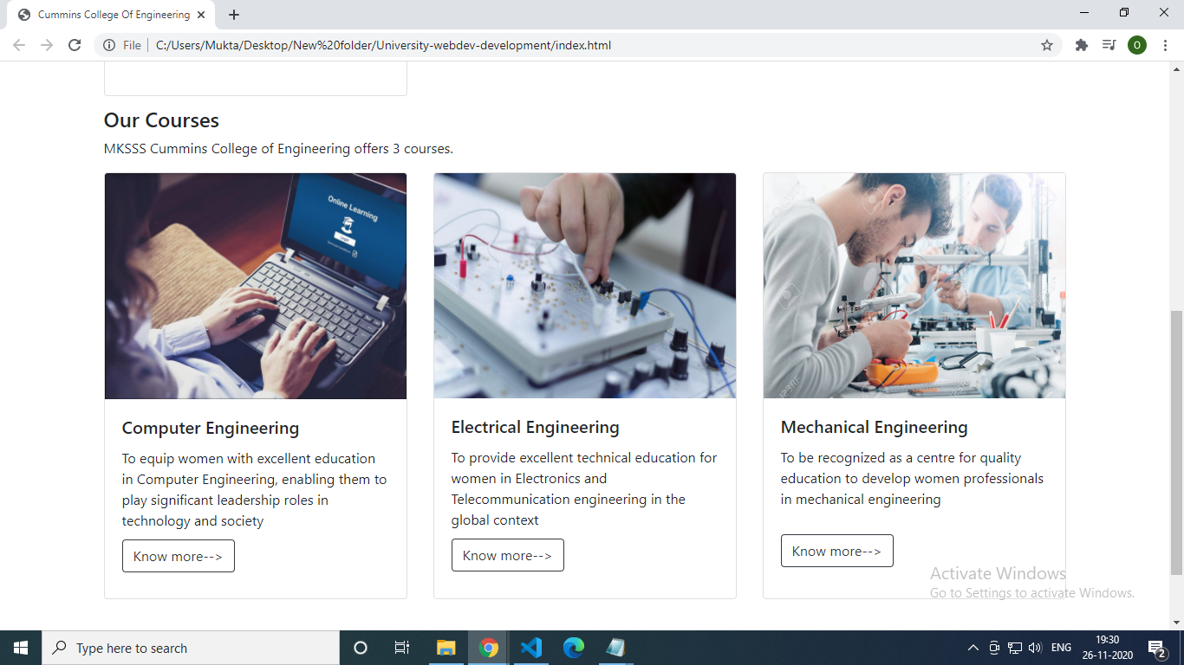

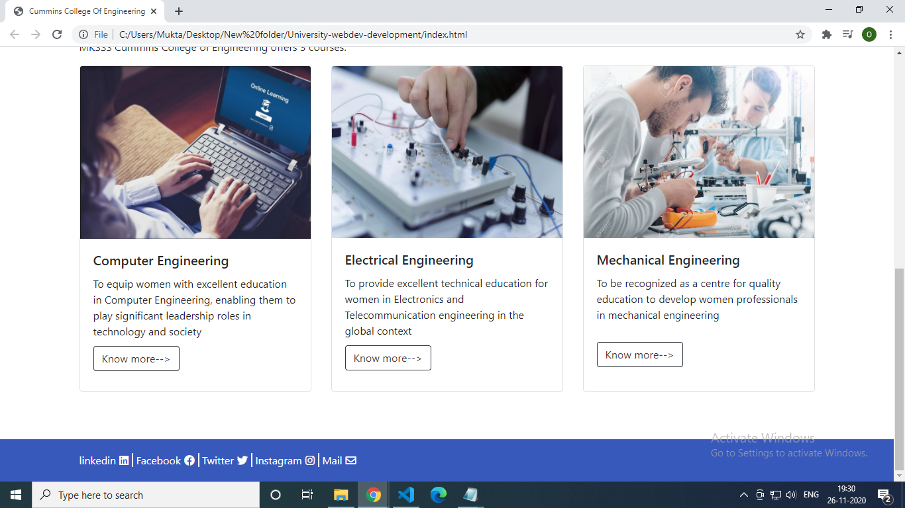

register.html

<!DOCTYPE html>

<html lang="en">

<head>

<title>Cummins College Of Engineering</title>

<meta charset="utf-8" />

<meta name="viewport" content="width=device-width, initial-scale=1" />

<link rel="stylesheet" href="https://maxcdn.bootstrapcdn.com/bootstrap/4.5.2/css/bootstrap.min.css" />

<link rel="stylesheet" href="./assets/style/style.css" />

<link rel="stylesheet" type="text/css"

href="https://cdnjs.cloudflare.com/ajax/libs/font-awesome/5.13.1/css/all.min.css">

<script src="https://ajax.googleapis.com/ajax/libs/jquery/3.5.1/jquery.min.js"></script>

<script src="https://cdnjs.cloudflare.com/ajax/libs/popper.js/1.16.0/umd/popper.min.js"></script>

<script src="https://maxcdn.bootstrapcdn.com/bootstrap/4.5.2/js/bootstrap.min.js"></script>

</head>

<body>

<header>

<div id="header-section" class="text-center">

<div class="container">

<div class="row">

<div class="col-md-6 col-sm-6 logo"></div>

<div class="col-md-6 col-sm-6">

<p class="mt-4">

MKSSS’s Cummins College of Engineering for Women,<br />Karvenagar,

Pune – 411052

</p>

</div>

</div>

</div>

</div>

<nav class="navbar navbar-expand-lg navbar-dark bg-dark static-top">

<div class="container">

<button class="navbar-toggler" type="button" data-toggle="collapse" data-target="#navbarResponsive"

aria-controls="navbarResponsive" aria-expanded="false" aria-label="Toggle navigation">

<span class="navbar-toggler-icon"></span>

</button>

<div class="collapse navbar-collapse" id="navbarResponsive">

<ul class="navbar-nav mr-auto">

<li class="nav-item">

<a class="nav-link" href="index.html">Home

<!-- <span class="sr-only">(current)</span> -->

</a>

</li>

<li class="nav-item">

<a class="nav-link active" href="register.html">Register</a>

<span class="sr-only">(current)</span>

</li>

<li class="nav-item">

<a class="nav-link" href="courses.html">Courses</a>

</li>

<li class="nav-item">

<a class="nav-link" href="contact.html">Contact Us</a>

</li>

</ul>

</div>

</div>

</nav>

</header>

<!---------------------------Registration Form----------------->

<div class="container">

<h4 class="my-4" >Registration form :</h4>

<div class="row mt-2">

<div class="col-md-7 px-4">

<form class="container-form" id="myForm" style="border: 0.2px solid #A9A9A9; border-radius: 5px; padding: 20px 20px 20px 20px;">

<div class="form-group" >

<label> Firstname : </label>

<input class="form-control" placeholder="Firstname" type="text" name="firstname" maxlength="15" required />

</div>

<div class="form-group">

<label> Lastname : </label>

<input class="form-control" placeholder="Lastname" type="text" name="lastname" maxlength="15" required />

</div>

<div class="form-group">

<label>

Course :

</label>

<select class="form-control" required>

<option value="">Select Course</option>

<option value="Comp" id="01">Computer Engineering</option>

<option value="elect" id="02">Electrical Engineering</option>

<option value="mech" id="03">Mechanical Engineering</option>

</select>

</div>

<div class="form-group" required>

<label>

Gender :

</label><br>

<div class="form-check">

<label class="form-check-label" >

<input type="radio" class="form-check-input" name="gender" value="male" required />Male

</label>

</div>

<div class="form-check">

<label class="form-check-label">

<input type="radio" class="form-check-input" name="gender" value="female" />Female

</label>

</div>

<div class="form-check"><label class="form-check-label">

<input type="radio" class="form-check-input" name="gender" value="other" />Others

</label>

</div>

</div>

<div class="form-group">

<label> Age : </label>

<input class="form-control" placeholder="Age" type="number" name="age" min="15" max="99" required />

</div>

<label>

Phone :

</label>

<div class="input-group" required>

<input type="text" class="form-control col-md-2 col-sm-3" name="country_code" size="2" value="+91"

maxlength="2" />

<input type="text" class="form-control col-md-10 col-sm-9" name="phone" type="number" maxlength="10" minlength="10"required />

</div><br>

<div class="form-group">

<label for="comment">Address:</label>

<textarea class="form-control" rows="5" id="address" required></textarea>

</div>

<div class="form-group">

<label> Email : </label>

<input class="form-control" placeholder="Email" type="email" name="email" maxlength="75" required/>

</div>

<div class="form-group">

<label> Password : </label>

<input class="form-control" placeholder="Password" type="password" name="password" required/>

</div>

<!-- <button type="button" class="btn btn-outline-dark" onclick="myFunction()" >Submit</button> -->

<!-- <input type="submit" value="submit"> -->

<button type="submit" class="btn btn-outline-primary">Submit</button>

</form>

</div>

<div class="col-md-5 px-3" style="border: 0.5px solid #A9A9A9;border-radius: 5px; padding: 20px 20px 20px 20px;">

<h4 class="padding-h4">Important Instructions :</h4><br>

Enter details in the form as in reference to any of your legal document.<br>

Any case of inaccurate details may lead to rejection of your admission form.<br><br>

<b>Additional documents for registration</b><br>

Bring this registration form and the following documentation to the College office.

<ul class="mt-4" style="list-style-position:inside">

<li style="list-style-position:inside">Original Birth Certificate</li>

<li>Original Aadhar Card</li>

<li>Original Marksheet of Std.12 or Diploma</li>

<li>Current Proof of Residence<br><span style="padding-left: 20px;"> (ex. power, water or gas bill)</span></li>

<li>Other</li>

</ul>

</p>

</div>

</div>

</div>

<!-- <script type="text/javascript">

function myFunction(){

document.getElementById("myForm").submit();

}

</script> -->

<!---------------------------Footer----------------->

<footer class="mt-5">

<div id="footer-section">

<div class="container">

<div class="container1">

<!-- <h3>Footer</h3> -->

<span><a href="https://www.linkedin.com" target="_blank">linkedin</a><i class="fab fa-linkedin"></i></span>

<span><a href="https://www.facebook.com" target="_blank">Facebook</a><i class="fab fa-facebook"

aria-hidden="true"></i></span>

<span> <a href="https://www.twitter.com" target="_blank">Twitter</a><i class="fab fa-twitter"

aria-hidden="true"></i></span>

<span> <a href="https://www.instagram.com" target="_blank">Instagram</a><i class="fab fa-instagram"

aria-hidden="true"></i></span>

<span> <a

href="mailto:support@gmail.com"

target="_blank">Mail</a><i class="far fa-envelope" aria-hidden="true"></i></span>

</div>

</div>

</div>

</footer>

</body>

</html>

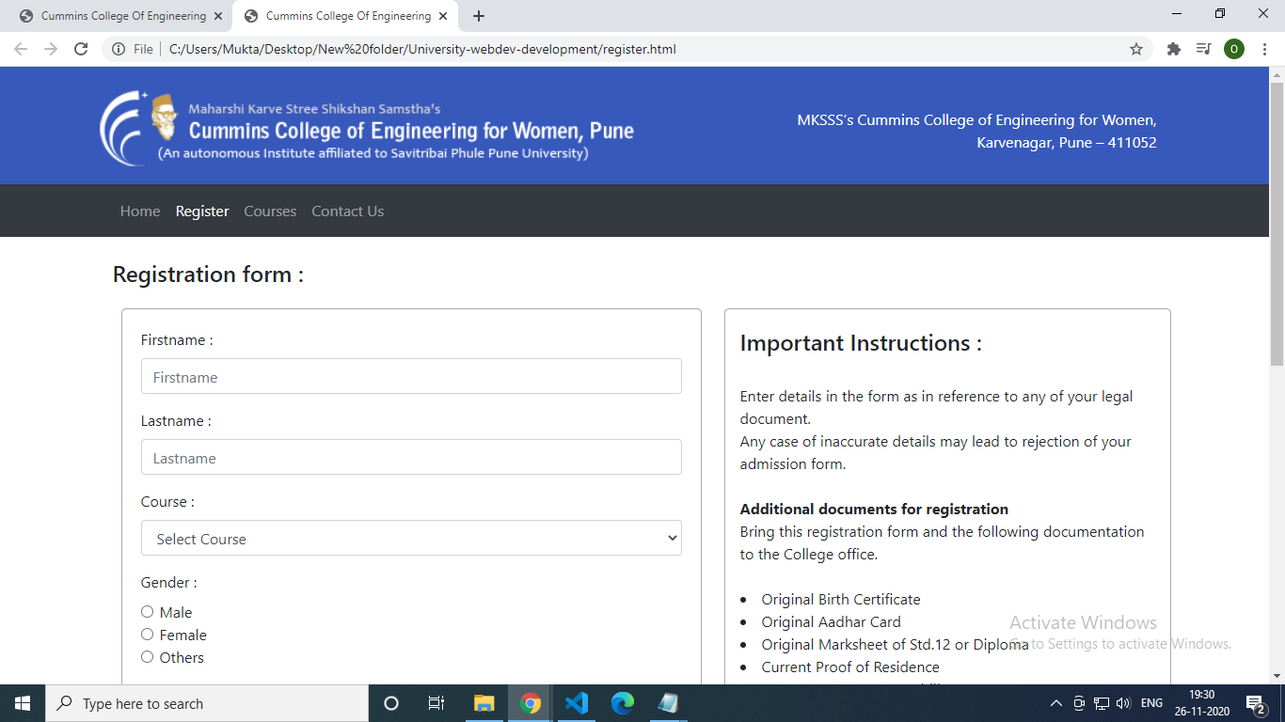

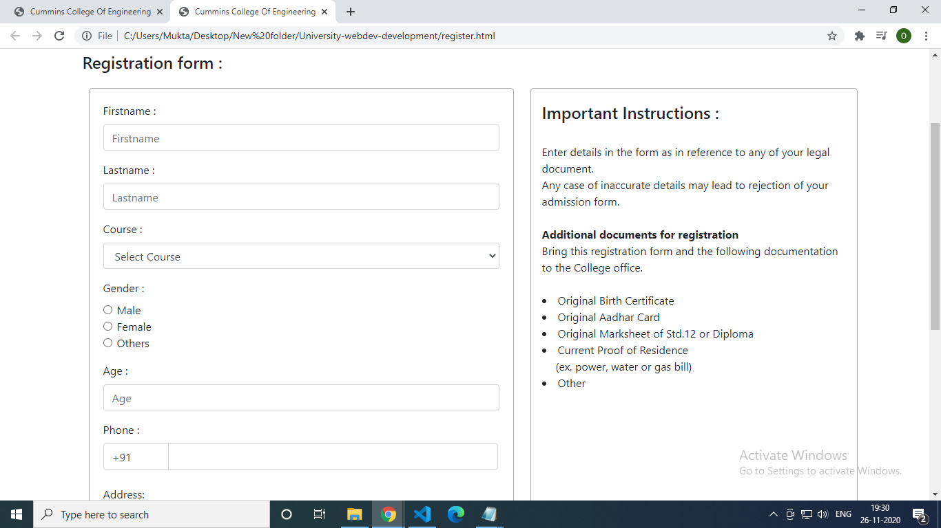

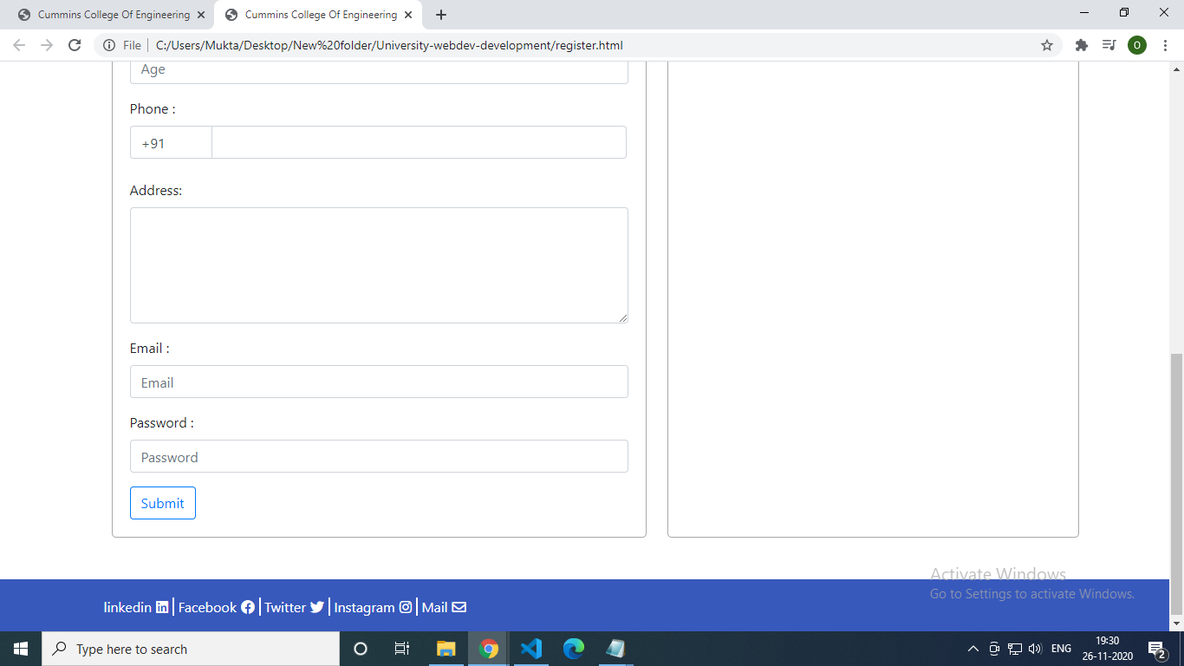

courses.html

<!DOCTYPE html>

<html lang="en">

<head>

<title>Cummins College Of Engineering</title>

<meta charset="utf-8" />

<meta name="viewport" content="width=device-width, initial-scale=1" />

<link rel="stylesheet" href="https://maxcdn.bootstrapcdn.com/bootstrap/4.5.2/css/bootstrap.min.css" />

<link rel="stylesheet" href="./assets/style/style.css" />

<link rel="stylesheet" type="text/css"

href="https://cdnjs.cloudflare.com/ajax/libs/font-awesome/5.13.1/css/all.min.css">

<script src="https://ajax.googleapis.com/ajax/libs/jquery/3.5.1/jquery.min.js"></script>

<script src="https://cdnjs.cloudflare.com/ajax/libs/popper.js/1.16.0/umd/popper.min.js"></script>

<script src="https://maxcdn.bootstrapcdn.com/bootstrap/4.5.2/js/bootstrap.min.js"></script>

</head>

<body>

<header>

<div id="header-section" class="text-center">

<div class="container">

<div class="row">

<div class="col-md-6 col-sm-6 logo"></div>

<div class="col-md-6 col-sm-6">

<p class="mt-4">

MKSSS’s Cummins College of Engineering for Women,<br />Karvenagar,

Pune – 411052

</p>

</div>

</div>

</div>

</div>

<nav class="navbar navbar-expand-lg navbar-dark bg-dark static-top">

<div class="container">

<button class="navbar-toggler" type="button" data-toggle="collapse" data-target="#navbarResponsive"

aria-controls="navbarResponsive" aria-expanded="false" aria-label="Toggle navigation">

<span class="navbar-toggler-icon"></span>

</button>

<div class="collapse navbar-collapse" id="navbarResponsive">

<ul class="navbar-nav mr-auto">

<li class="nav-item">

<a class="nav-link" href="index.html">Home

<!-- <span class="sr-only">(current)</span> -->

</a>

</li>

<li class="nav-item">

<a class="nav-link" href="register.html">Register</a>

<span class="sr-only">(current)</span>

</li>

<li class="nav-item active">

<a class="nav-link" href="courses.html">Courses</a>

</li>

<li class="nav-item">

<a class="nav-link" href="contact.html">Contact Us

<!-- <span class="sr-only">(current)</span> -->

</a>

</li>

</ul>

</div>

</div>

</nav>

</header>

<!---------------------------Courses----------------------------->

<div class="courses container">

<h4 class="my-4">Our Courses :</h4>

<div class="comp my-5" id="001" style="border: 0.5px solid;; padding: 20px 20px 20px 20px;border-radius: 10px;">

<h4>Computer Engineering</h4>

<p>Established in the year 1992, the Department of Computer Engineering and Information Technology is one of the

youngest departments in the institute. The under graduate course in Computer Engineering was started in 1992 and

in Information Technology in 2000. Both these courses have intake of 60 students each. There is also timely

introduction of postgraduate course in Computer Engineering since 1997 with the intake of 18. The department is

also a recognized research centre under University of Pune for its PhD program. The department boasts of a

highly qualified faculty who perform research according to the needs of the society and then teach the students.

It promotes open source software development and its student's have been closely involved with such development

projects. The students of this department have brought several laurels to this institute by actively

participating and winning several technical competitions of international stature. Needless to mention, the

placement records for the department have been nothing short of magnificent having students placed in renowned

companies in India as well as out of India.</p>

<h6>HOD : Prof. A B C</h6>

<h6>Email: hod.comp@cumminscollege.in</h6>

<a href="register.html#01"><button style="margin: 10px 0" ; type="button"

class="btn btn-outline-dark">Register</button></a>

</div>

<div class="electric comp my-5" id="002" style="border: 0.5px solid;; padding: 20px 20px 20px 20px;border-radius: 10px;">

<h4>Electrical Engineering</h4>

<p>The Department established in 1932, running UG program since 1932 and PG programs in Power Systems and Control

Systems since 1952. It has 83 years long history of technical education. Electrical engineers produced by this

department have contributed to industrial development over the last 78 years at national and international

level. The Department has team of 21 faculty members and well qualified staff. It presently has well equipped

laboratories and excellent computational facilities. World class software like MATLAB, Simu-link, PSCAD, ETAP,

MULTISIM, PSIM, Proteus, Lab view, MAGNET are available in the department to work on top-of-the line projects in

various areas of electrical engineering. The indigenously developed laboratory set ups are attracting the

attention of elite institutes including the IITs. Some of these set ups are first-of-its-kind in the country.

The department is always enthusiastic in conducting various courses and workshops for the faculty and students

to permeate advances in technology. All undergraduate, postgraduate and Ph.D. students thereby get full

opportunity to participate in co-curricular and extra-curricular activities leading to a holistic personality

development.</p>

<h6>HOD : Prof. P Q R</h6>

<h6>Email: hod.elec@cumminscollege.in</h6>

<a href="register.html#02"><button style="margin: 10px 0" ; type="button" class="btn btn-outline-dark">Register</button></a>

</div>

<div class="mech comp" id="003" style="border: 0.5px solid;; padding: 20px 20px 20px 20px;border-radius: 10px;">

<h4>Mechanical Engineering</h4>

<p>The Department of Mechanical Engineering was established in the year 1912. At present, the department offers

Graduate, Post Graduate and Doctorate degree courses. It is highly reputed for producing eminent engineers as

professionals, researchers and entrepreneurs. Many of its alumni occupy key positions in industries and

institutions in India as well as in abroad. The department is proud to be collaborated with well-known

industries in the sector.To achieve the goal, the department strives to generate high quality graduates through

rigorous coursework and cutting-edge research activities. The students in the department are exposed to the

problems faced by today’s societies, and are trained to address those problems through innovative thinking to

develop appropriate technological solutions. The faculty members of the department drive these activities

through their teaching and diverse research programs, covering numerous facets of Mechanical Engineering Science

and Applications. In addition to the regular academic work, the students of the department are encouraged to

participate in co-curricular activities.</p>

<h6>HOD : Prof. X Y Z</h6>

<h6>Email: hod.mech@cumminscollege.in</h6>

<a href="register.html#03"><button style="margin: 10px 0" ; type="button" class="btn btn-outline-dark">Register</button></a>

</div>

</div>

<!---------------------------Footer----------------->

<footer class="mt-5">

<div id="footer-section">

<div class="container">

<div class="container1">

<!-- <h3>Footer</h3> -->

<span><a href="https://www.linkedin.com" target="_blank">linkedin</a><i class="fab fa-linkedin"></i></span>

<span><a href="https://www.facebook.com" target="_blank">Facebook</a><i class="fab fa-facebook"

aria-hidden="true"></i></span>

<span> <a href="https://www.twitter.com" target="_blank">Twitter</a><i class="fab fa-twitter"

aria-hidden="true"></i></span>

<span> <a href="https://www.instagram.com" target="_blank">Instagram</a><i class="fab fa-instagram"

aria-hidden="true"></i></span>

<span> <a

href="mailto:support@gmail.com"

target="_blank">Mail</a><i class="far fa-envelope" aria-hidden="true"></i></span>

</div>

</div>

</div>

</footer>

</body>

</html>

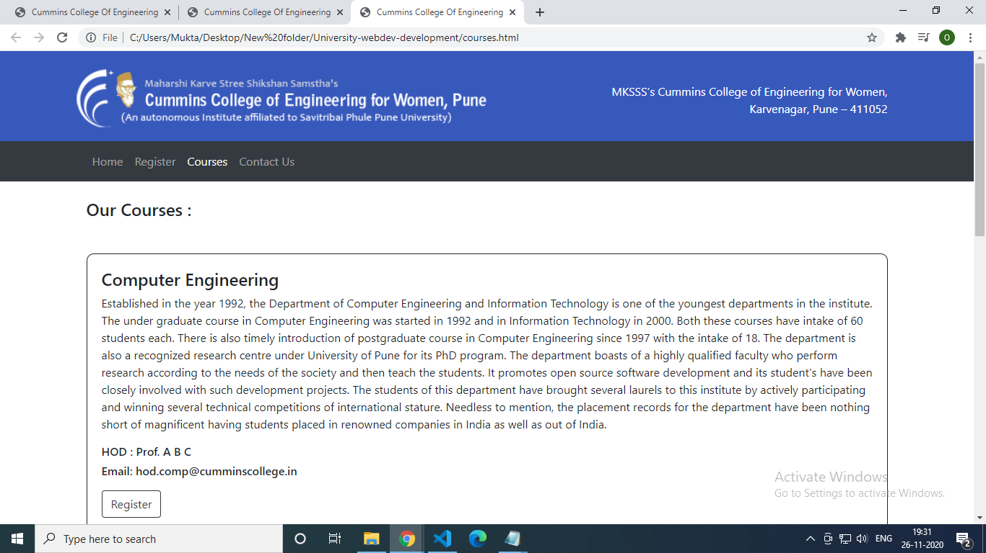

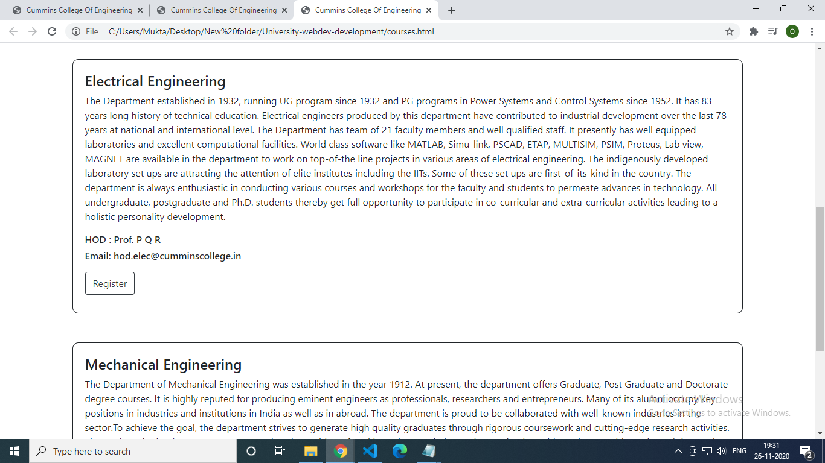

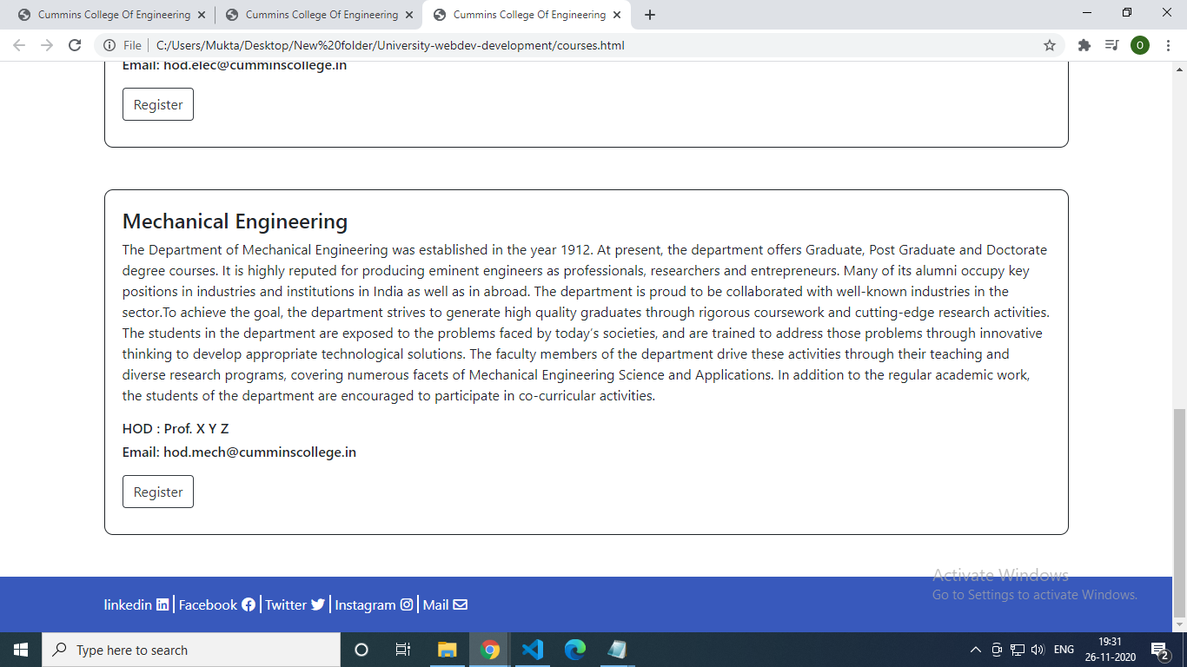

contact.html

<!DOCTYPE html>

<html lang="en">

<head>

<title>Cummins College Of Engineering</title>

<meta charset="utf-8" />

<meta name="viewport" content="width=device-width, initial-scale=1" />

<link rel="stylesheet" href="https://maxcdn.bootstrapcdn.com/bootstrap/4.5.2/css/bootstrap.min.css" />

<link rel="stylesheet" type="text/css"

href="https://cdnjs.cloudflare.com/ajax/libs/font-awesome/5.13.1/css/all.min.css">

<link rel="stylesheet" href="./assets/style/style.css" />

<script src="https://ajax.googleapis.com/ajax/libs/jquery/3.5.1/jquery.min.js"></script>

<script src="https://cdnjs.cloudflare.com/ajax/libs/popper.js/1.16.0/umd/popper.min.js"></script>

<script src="https://maxcdn.bootstrapcdn.com/bootstrap/4.5.2/js/bootstrap.min.js"></script>

</head>

<body>

<header>

<div id="header-section" class="text-center">

<div class="container">

<div class="row">

<div class="col-md-6 col-sm-6 logo"></div>

<div class="col-md-6 col-sm-6">

<p class="mt-4">

MKSSS’s Cummins College of Engineering for Women,<br />Karvenagar,

Pune – 411052

</p>

</div>

</div>

</div>

</div>

<nav class="navbar navbar-expand-lg navbar-dark bg-dark static-top">

<div class="container">

<button class="navbar-toggler" type="button" data-toggle="collapse" data-target="#navbarResponsive"

aria-controls="navbarResponsive" aria-expanded="false" aria-label="Toggle navigation">

<span class="navbar-toggler-icon"></span>

</button>

<div class="collapse navbar-collapse" id="navbarResponsive">

<ul class="navbar-nav mr-auto">

<li class="nav-item ">

<a class="nav-link" href="index.html">Home

<!-- <span class="sr-only">(current)</span> -->

</a>

</li>

<li class="nav-item">

<a class="nav-link" href="register.html">Register</a>

<!----- <span class="sr-only">(current)</span>--->

</li>

<li class="nav-item">

<a class="nav-link" href="courses.html">Courses</a>

</li>

<li class="nav-item active">

<a class="nav-link" href="contact.html">Contact Us

<span class="sr-only">(current)</span>

</a>

</li>

</ul>

</div>

</div>

</nav>

</header>

<!---------------------------Registration Form----------------->

<div class="container">

<h4 class="my-4">Contact us :</h4>

<div class="my-3">

<h5>Please fill out the details:</h5>

<p>We will reach out to you as soon as possible!</p>

</div>

<div class="row">

<div class="form-border col-md-8">

<form class="container-form" id="myForm" style="border: 0.5px solid #A9A9A9; border-radius: 5px; padding: 20px 20px 20px 20px;">

<div class="form-group" >

<label> Name : </label>

<input class="form-control" placeholder="Name" type="text" name="name" maxlength="15" required />

</div>

<label>

Phone :

</label>

<div class="input-group">

<input type="text" class="form-control col-md-2 col-sm-3" name="country_code" size="2" value="+91"

maxlength="2" />

<input type="text" class="form-control col-md-10 col-sm-9" name="phone" type="number" maxlength="10" minlength="10" required />

</div><br>

<div class="form-group">

<label for="comment">Issue:</label>

<textarea class="form-control" rows="5" id="address" required></textarea>

</div>

<div class="form-group">

<label> Email : </label>

<input class="form-control" placeholder="Email" type="email" name="email" maxlength="75" required />

</div>

<br>

<!-- <button type="button" class="btn btn-outline-dark" onclick="myFunction()">Submit</button> -->

<button type="submit" class="btn btn-outline-primary">Submit</button>

</form>

</div>

</div>

</div>

<!-- <script type="text/javascript">

function myFunction() {

document.getElementById("myForm").submit();

} -->

</script>

<!---------------------------Footer----------------->

<footer class="mt-5">

<div id="footer-section">

<div class="container">

<div class="container1">

<span><a href="https://www.linkedin.com" target="_blank">linkedin</a><i class="fab fa-linkedin"></i></span>

<span><a href="https://www.facebook.com" target="_blank">Facebook</a><i class="fab fa-facebook"

aria-hidden="true"></i></span>

<span> <a href="https://www.twitter.com" target="_blank">Twitter</a><i class="fab fa-twitter"

aria-hidden="true"></i></span>

<span> <a href="https://www.instagram.com" target="_blank">Instagram</a><i class="fab fa-instagram"

aria-hidden="true"></i></span>

<span> <a

href="mailto:support@gmail.com"

target="_blank">Mail</a><i class="far fa-envelope" aria-hidden="true"></i></span>

</div>

</div>

</div>

</footer>

</body>

</html>

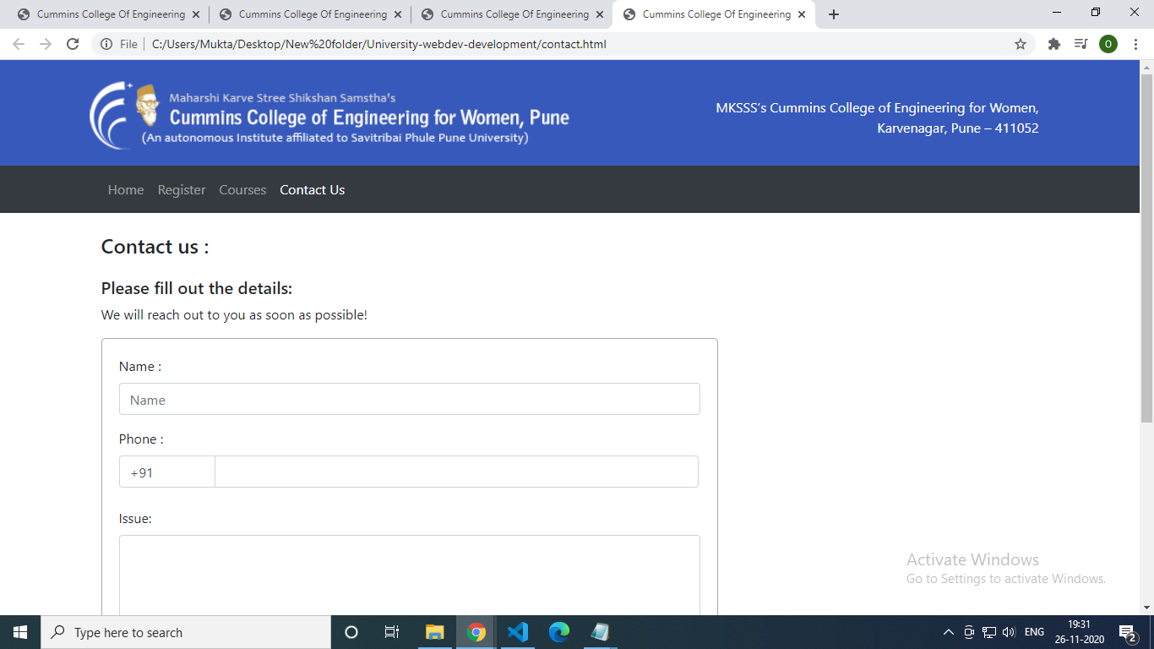

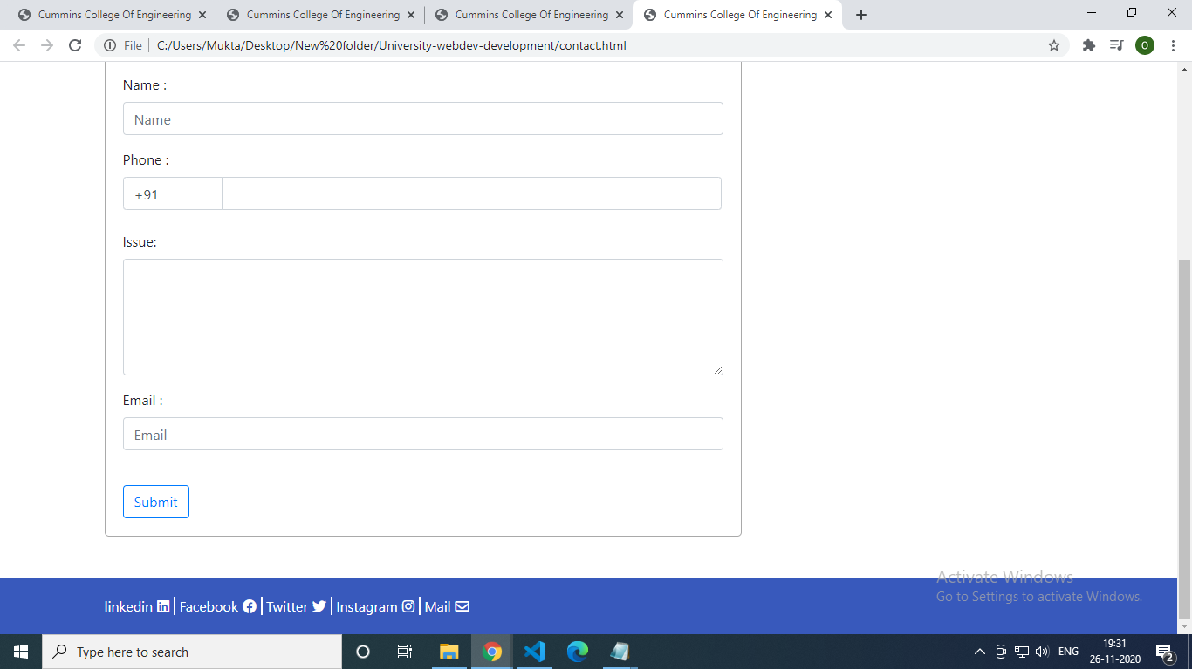

style.css

* {

margin: 0;

padding: 0;

font-size: 16px;

}

header #header-section {

background-color: #3859bc;

padding: 20px 0 15px;

}

header #header-section .logo {

background-image: url("../img/logo.png");

background-position: 0;

background-repeat: no-repeat;

background-size: contain;

min-height: 90px;

}

header #header-section p {

color: #fff;

text-align: right;

}

footer #footer-section {

background-color: #3859bc;

padding: 20px 0 20px;

}

footer #footer-section h3 {

color: #fff;

}

.main-container {

min-height: 70vh;

}

#footer-section a, #footer-section i{

color:#fff;

margin-right: 5px;

text-decoration: none;

}

#footer-section span{

border-right: 2px solid #fff;

}

#footer-section span:last-child{

border-right: none;

}